DIRECT DEPOSIT SIGN-UP



To access WebAdvisor go to:

MyPortal on Reedley College Website

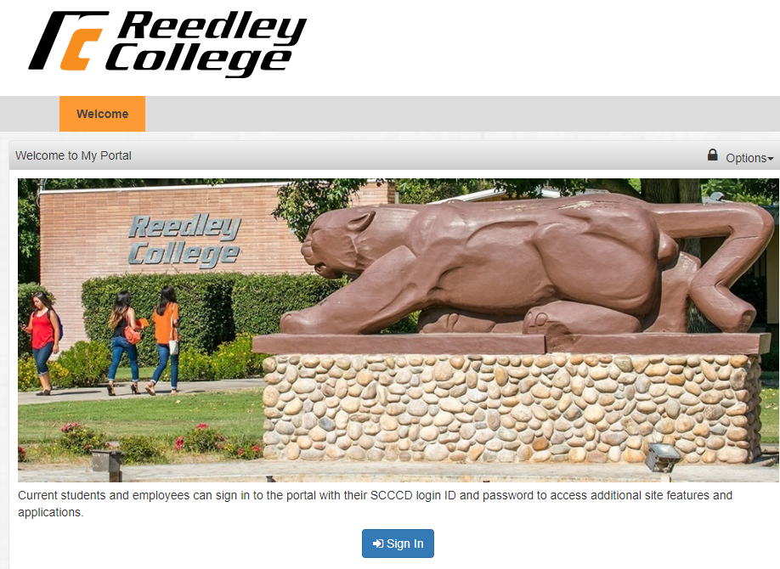

**Login ID & Password**

To view your personal records, you must enter a login ID and password.

**Login ID:**

Your login ID is in this format: studentID#

Example: 0123456

**Initial Password:**

The first time you log in to WebAdvisor, your password will be first initial (upper case), your last initial (lower case), and your 6-digit date of birth.

Example: **Js010197**

* The first time you access WebAdvisor, you will be prompted to choose a new password.
* Your new password MUST be 6 to 9 characters long and MUST include **both letters *and* numbers**.
* We encourage you to use the password “hint” in case you lose or forget your password in the future.
* **Remember your Password**
* Do not give your login ID or password to anyone. Keep your login ID and password in a safe place.
* Now you can Sign-up for Direct Deposit 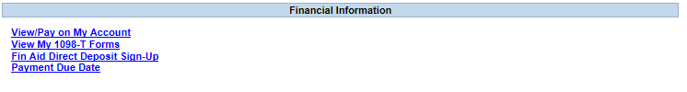
* WebAdvisor Help – call 559.442.8236

