Quick Step Guide for Service Requests
How to Register/Log in

- Open your Internet Browser. Type the following into the web address bar: www.myschoolbuilding.com: , or click on this link: www.myschoolbuilding.com. Press the Enter key or click on Go. Enter the account number 1008091648 then click on Submit Organization. Or you can use the following link to access the login page:

https://www.myschoolbuilding.com/myschoolbuilding/mygateway.asp?acctnum=1008091648

HELPFUL INFORMATION: You can create a shortcut to your desktop, find a blank area on this screen and right click on your mouse. You will have the option to create a shortcut or add to your favorites. Creating a shortcut will add an icon to your desktop. You can double click it the next time you want to sign in.

2) You will be prompted to enter your email address then click Submit. If you have been to this website before and have entered a maintenance request into the system, you are already registered as a user. Enter your email address then proceed to page 2, “How to Submit a request”.

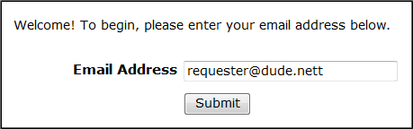

3) If you are a new user, the system will not recognize you right away. Enter your last name to proceed with the registration process. Click Submit to continue.

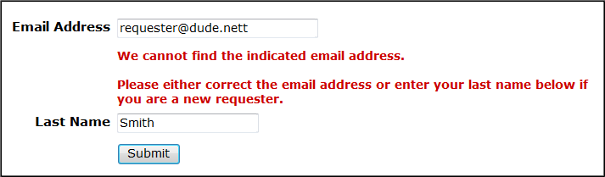

4) Enter your first name then click Submit. The Phone, Cell Number, and Pager fields are optional; however you may be required to enter your phone number on the next page.

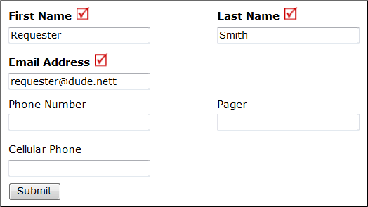
How to Submit a Request

- Make sure you are on the Maint Request tab at the top of the screen.

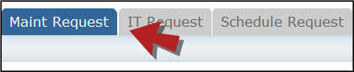

NOTE: ANY FIELD MARKED WITH IS A REQUIRED FIELD

Step 1: This will be filled in with your contact information according to how it was entered upon registration.
Step 2: Click on the drop down menu next to Location and make your selection. This will indicate where the work will be performed.

  - Follow the same steps for Building and Area (*if selections are available).
  - Be sure to type in your Area/Room Number.

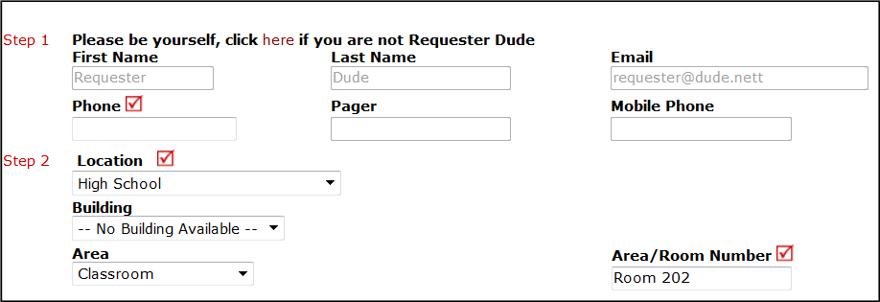

Step 3: Select the icon that best describes the request/issue you are reporting.

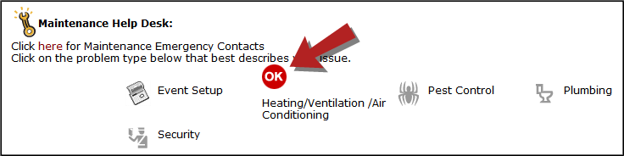

- Step 4: Type in your description of the problem.
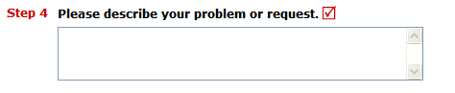

Optional steps that may appear on your page: (Some may be required)

Next Step: Type in the best time for a technician to come by.
Next Step: Click on the drop down arrow and select a Purpose Code.
Next Step: Use calendar to select a Requested Completion Date.
Next Step: Click the Attach New File link to attach a photo or document detailing the issue

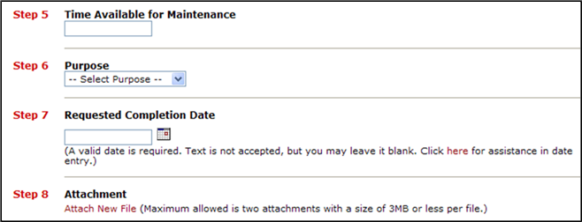

- Next Step: Type in the Submittal Password of: schooldude
- Last Step: Click the Submit button.

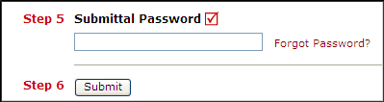
My Requests Tab

You can view any requests that you have entered into the system by clicking on the My Requests tab. Hover your mouse over the Shortcuts link and click on My Maint Requests. You will see a listing of any request that you have entered into the system. You are also able to print out a listing of your requests by clicking on the printer icon.

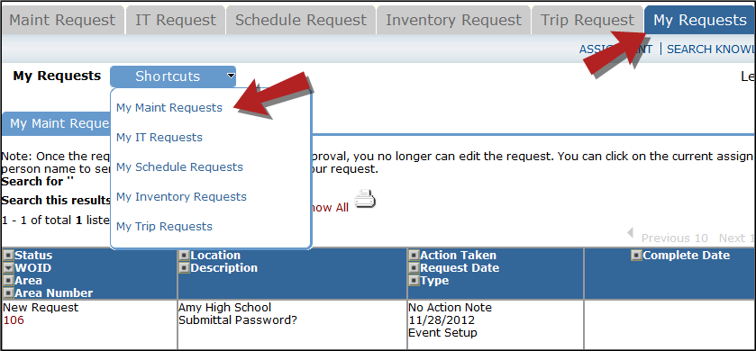

On this screen you will see up-to-date information on your request including:
- Status
- Work Order number for referencing.
- The date you requested the work.
- Any Action Taken notes added by the technician of the progress of the work order.
- A Completion Date once the work has been completed.

TIPS:
- In the Request Totals section (on the right hand side of the screen) you can click on the number next to the status description to see all request marked with that status.
- You can search for any work order request by typing in a keyword in the box next to Search this results for then click on GO. This will pull up any of your requests according to the keyword that you searched for. (Example: If you type in “Keys”, it would have pulled up any request dealing with keys).
- Click on the Work Request Tab to input a new request.

Need Help?

There are several ways to get help for any questions that you may have. Click on the Help link located in the upper right hand corner of your screen.

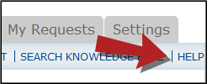

Once you click on Help link, you will see a screen which will list a few help options. If included, you will see a listing of local phone numbers that can be used to contact someone within your organization. Additionally, you will see a link to download the MaintenanceDirect Requester Manual as well as being able to access the Online Help page.

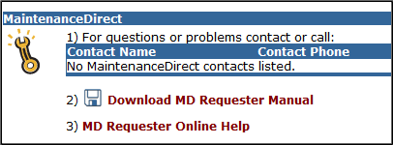

If you select the MD Requester Online Help option you can click on the links under the Table of Contents heading. These headings will explain further how to navigate through the MySchoolBuilding.com page. In the User Guides section you will find an interactive help movie which will walk you through the steps of entering in a new request.

