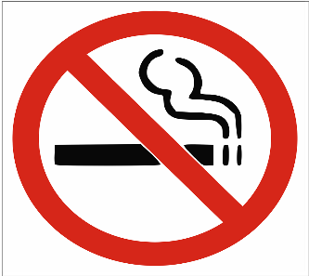 10 Health Risks from Smoking:
- About 80% of Lung Cancers are caused by smoking.
- Smoking is a major cause of Strokes—Blood clot in the brain.
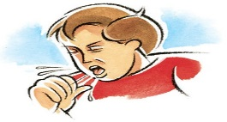
- Smoking damages the airways in the lungs, leading to Emphysema and Chronic Bronchitis (COPD).
- Smoking causes Cancers of the Mouth, Nose, Throat, and Esophagus.
- Smoking increases the risk of Osteoporosis.
- Smoking decreases the body’s ability to fight off Infection.
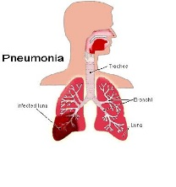
- Smokers Cough and Wheeze more than nonsmokers, leading to higher risk of Pneumonia.

- Smoking increases the risk for Type 2 Diabetes
- Smoking can lead to Cancers of the Stomach, Bladder, and Pancreas.
- Smoking hardens the arteries, which increases
the risk of Heart Attack.
References: www.CDC.gov/tobacco
www.smokefree.gov

